EXPERIMENT 4: CREATION OF REPORTS USING ZOHO CREATOR

Aim
To create and configure reports in Zoho Creator for the WattWise – Household Energy Habit Analyzer application to display, organize, filter and analyze appliance details, electricity readings, energy audit results, energy-saving actions and maintenance records.

Procedure
- Opened the WattWise application in Zoho Creator.
- Created the required forms to store appliance information, meter readings, energy audits, energy-saving actions and appliance maintenance details.
- Opened the reports automatically generated for the respective forms.
- Configured the Appliance Registry Report to display appliance names, appliance categories, household areas, brands, model numbers, wattage, quantity and appliance status.
- Configured the Meter Reading Log Report to display reading dates, meter readings, previous readings, units consumed, average daily consumption and estimated bill amounts.
- Configured the Energy Audit & Analysis Report to display audit titles, audit periods, selected appliances, estimated consumption, meter consumption and audit status.
- Configured the Energy Saving Action Tracker Report to display action titles, related audits, related appliances, priorities, target completion dates, expected energy savings and action status.
- Configured the Appliance Maintenance & Service Report to display appliance details, issue categories, severity, assigned technicians, service costs and maintenance dates.
- Arranged the report columns in a meaningful order and configured sorting wherever available.
- Verified the reports using the available sample records and checked whether the information was displayed correctly.

Observation
The reports in Zoho Creator provided a structured view of the records stored in the WattWise application. The List report format displayed multiple records in rows and their corresponding field values in columns.
The Appliance Registry Report displayed appliance specifications such as appliance name, category, household area, brand and model number. The Meter Reading Log Report organized electricity readings and consumption-related information. The Energy Audit & Analysis Report displayed audit details and estimated energy consumption. The Energy Saving Action Tracker Report helped track energy-saving activities, priorities and deadlines. The Appliance Maintenance & Service Report organized service requests, appliance faults, repair costs and maintenance schedules.
The reports were linked to their respective forms, allowing the stored records to be viewed without creating duplicate data-entry forms. Sorting options helped organize records according to dates and other relevant fields. These reports can also support further analysis through filters, dashboards and calculated fields.
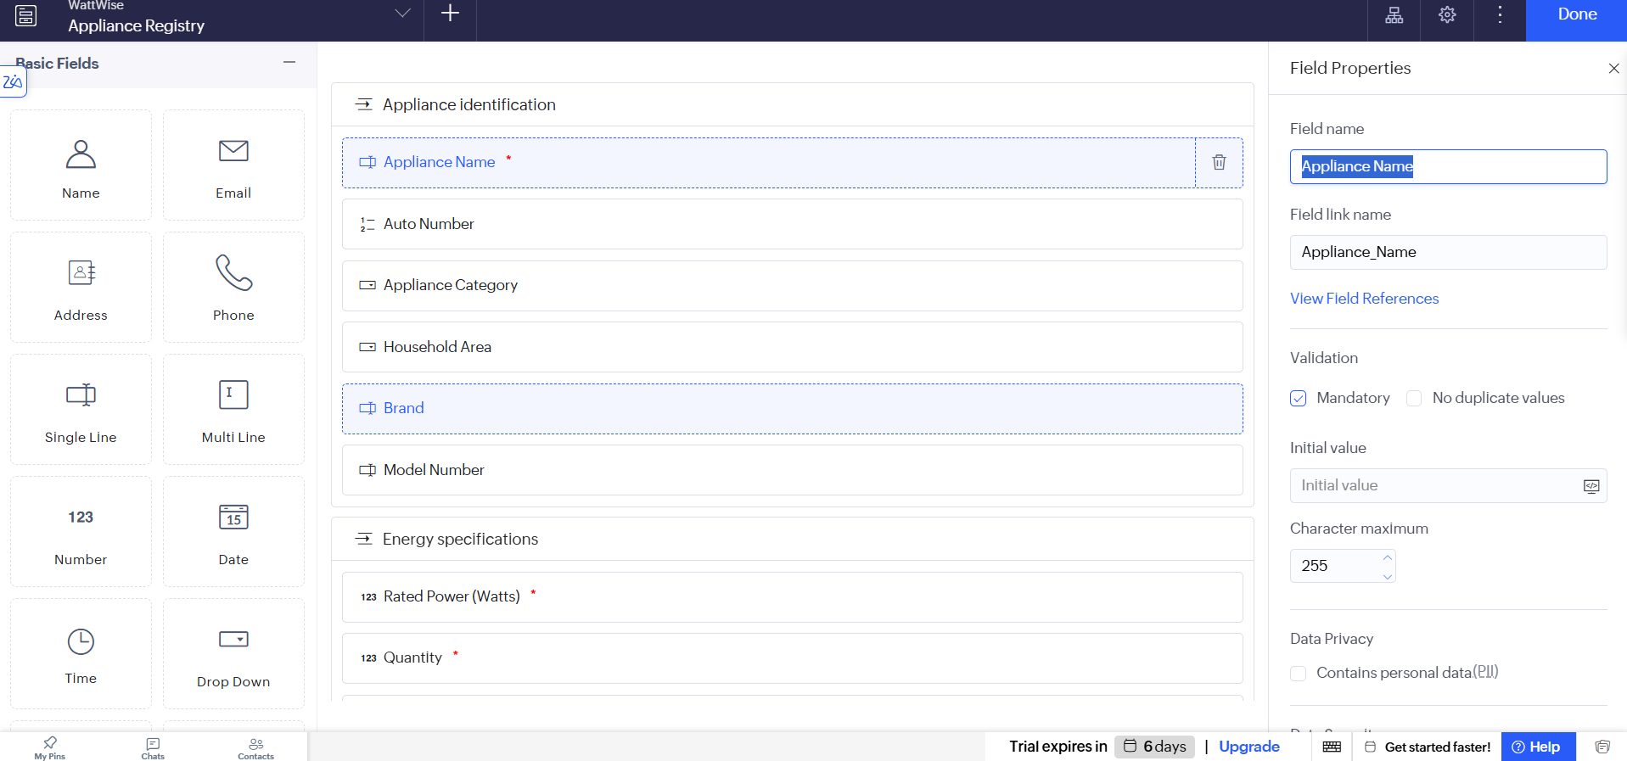
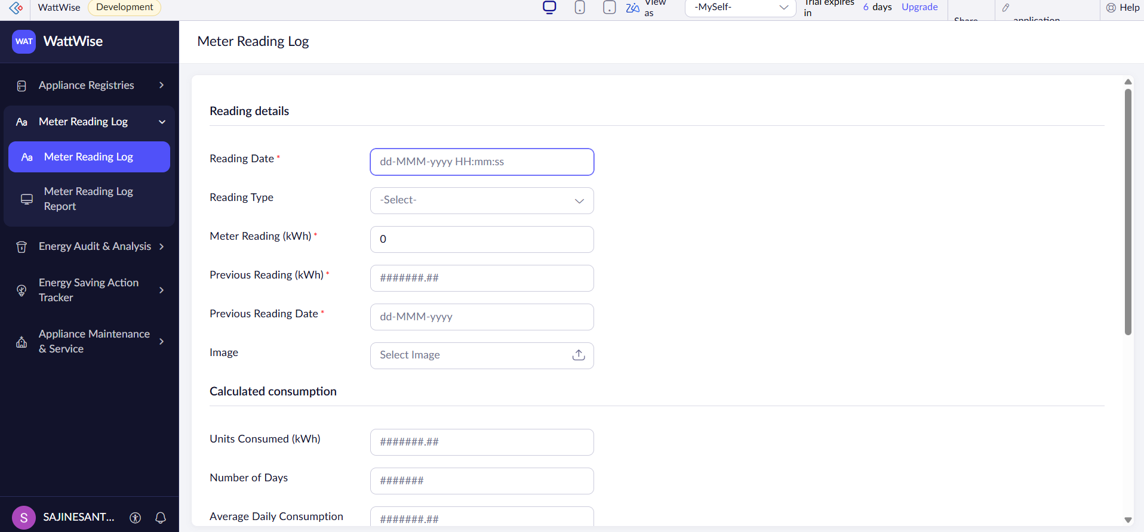
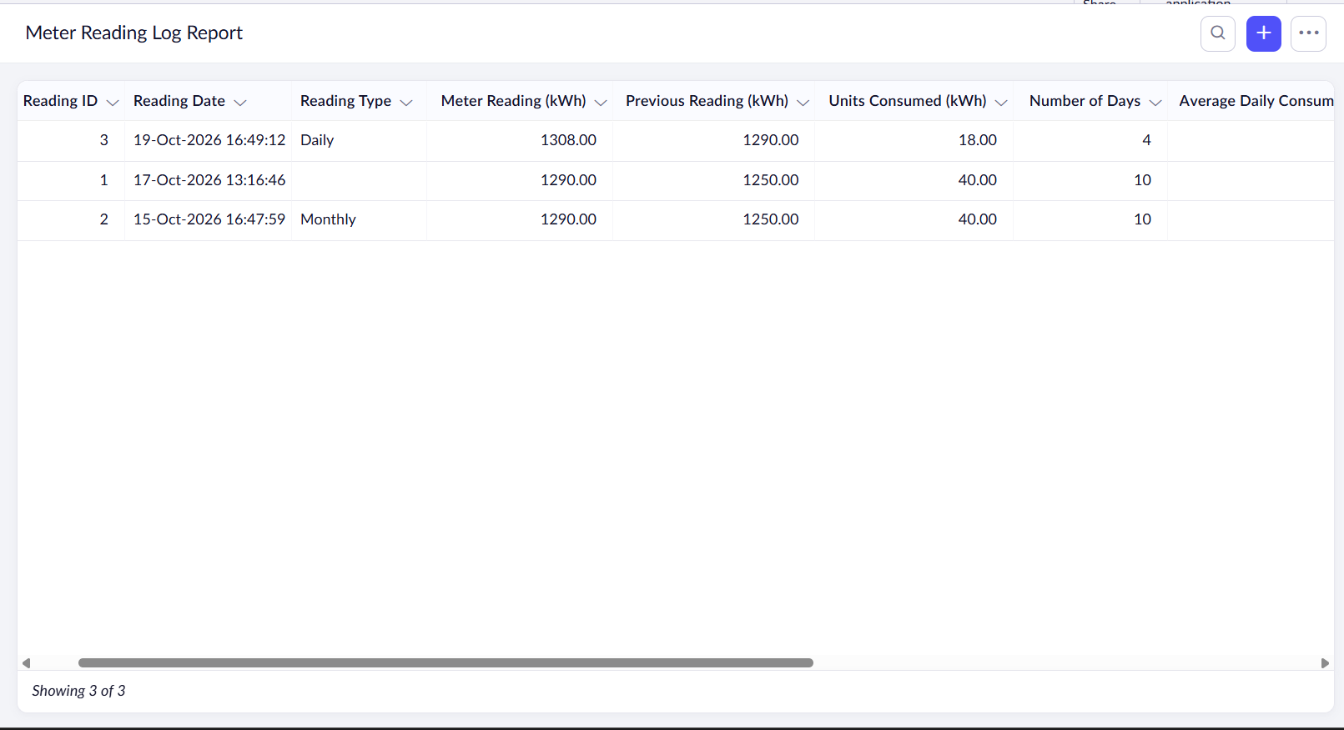
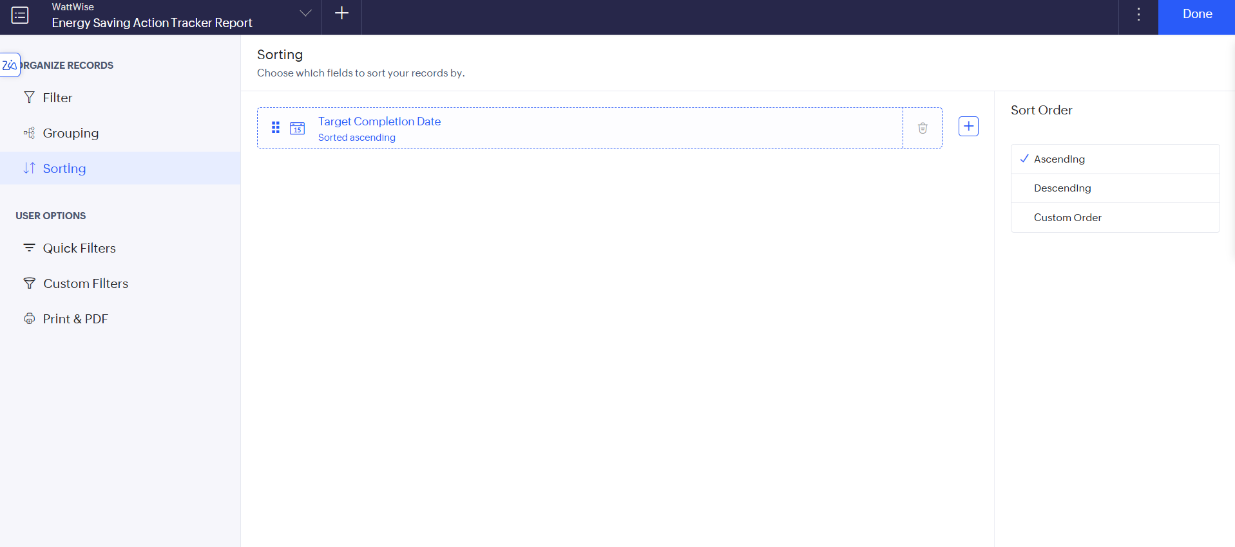

Result
Successfully created and configured five reports in the WattWise application using Zoho Creator. The reports organize appliance information, electricity readings, energy audits, energy-saving actions and maintenance records for easier monitoring and analysis.

Conclusion
The experiment demonstrated how Zoho Creator reports can be used to present application data in a structured and meaningful manner. The configured reports provide a foundation for developing dashboards, implementing Deluge calculations and automating energy-monitoring activities in the WattWise application.

